CHAPTER 4
SYSTEM DESIGN
System design is the process of defining the architecture, components, modules, interfaces, and data for a system to satisfy specified requirements. It bridges the gap between requirements analysis and system implementation.
4.1 BASIC MODULES
Basic modules are the main functional sections into which the system is divided so that it is easier to develop, understand, and maintain.
MODULES
- User Management Module
- Campaign Management Module
- Donation Processing Module
- Report & Analytics Module
- Notification Module
- Authentication Module
- Database Module
User Management Module: The User Management Module handles all operations related to users, such as donors, campaign creators, and administrators. It manages user registration, profile updates, access control, and role-based permissions to ensure that each type of user interacts with the system according to their privileges.
Campaign Management Module: The Campaign Management Module allows users (mainly campaign creators and admins) to create, update, monitor, and close fundraising campaigns. It manages campaign details such as title, description, goal amount, progress tracking, and status.
Donation Processing Module: The Donation Processing Module manages all donation-related operations. It handles receiving contributions from donors, validating payment details, recording transactions, and linking donations to the respective campaigns.
Authentication Module: The Authentication Module ensures that only authorized users can access the system. It manages login, registration, password encryption, and secure session handling to protect sensitive information like user credentials and donation details.
Report & Analytics Module: The Report & Analytics Module generates, displays, and exports reports related to donations and campaigns. It provides insights such as total funds raised, donor contributions, campaign performance, and trends to help admins and campaign owners make informed decisions.
Notification Module: The Notification Module is responsible for sending alerts and updates to users. Donors receive confirmation messages after making contributions, campaign owners receive progress updates, and admins get alerts on important system activities. Notifications can be sent via email or in-app messages.
Database Module: The Database Module stores, retrieves, updates, and manages all system data. It acts as the central hub for user details, campaign information, donation records, authentication data, and reports. In this project, it ensures data integrity, security, and fast retrieval for smooth system operations.
4.2 DATA DESIGN
Data design in this project is the process of structuring and organizing the information related to users, campaigns, and donations so that it can be stored, retrieved, and updated efficiently. It acts as the blueprint for how data will flow within the system and ensures that every module works with consistent and reliable information.
- Ensure completeness: All required data such as user details, campaign information, and donation records are properly captured.
- Improve efficiency: Data storage is optimized to reduce complexity and enable fast access.
- Maintain consistency: Redundancy is minimized so that duplicate or conflicting information does not exist in the database.
- Support integration: Smooth communication between modules (e.g., User Management, Campaign Management, Donation Processing) is enabled by well-structured relationships.
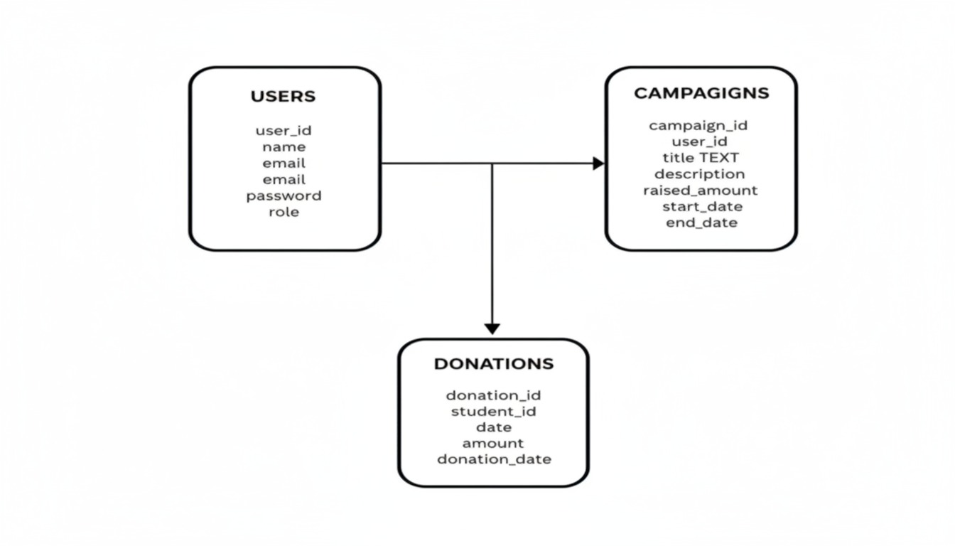
Figure 4.1 Schema design
4.3 PROCEDURAL DESIGN
Procedural design in this project defines the sequence of operations, workflows, and the way different system components interact to achieve the intended functionality. It helps in structuring the system into smaller, manageable processes that can be easily understood, developed, and maintained.
4.3.1 LOGICAL DIAGRAM
A logical diagram is a visual representation that shows how different parts of a system are logically connected - focusing on the flow of information, processes, and relationships, rather than the physical details of implementation.
- Users (Creators, Donors, Admins) interact with the system through the User Interface (Frontend).
- The Application Layer (Backend) processes requests such as campaign creation, donations, authentication, and reporting.
- The Database Layer (Supabase/PostgreSQL) stores all user, campaign, and donation data.
- The Payment Gateway ensures secure transactions for donations.
USE CASE DIAGRAM
A Use Case Diagram visually represents how different actors interact with the Digital Fundraising Portal System to achieve specific goals.
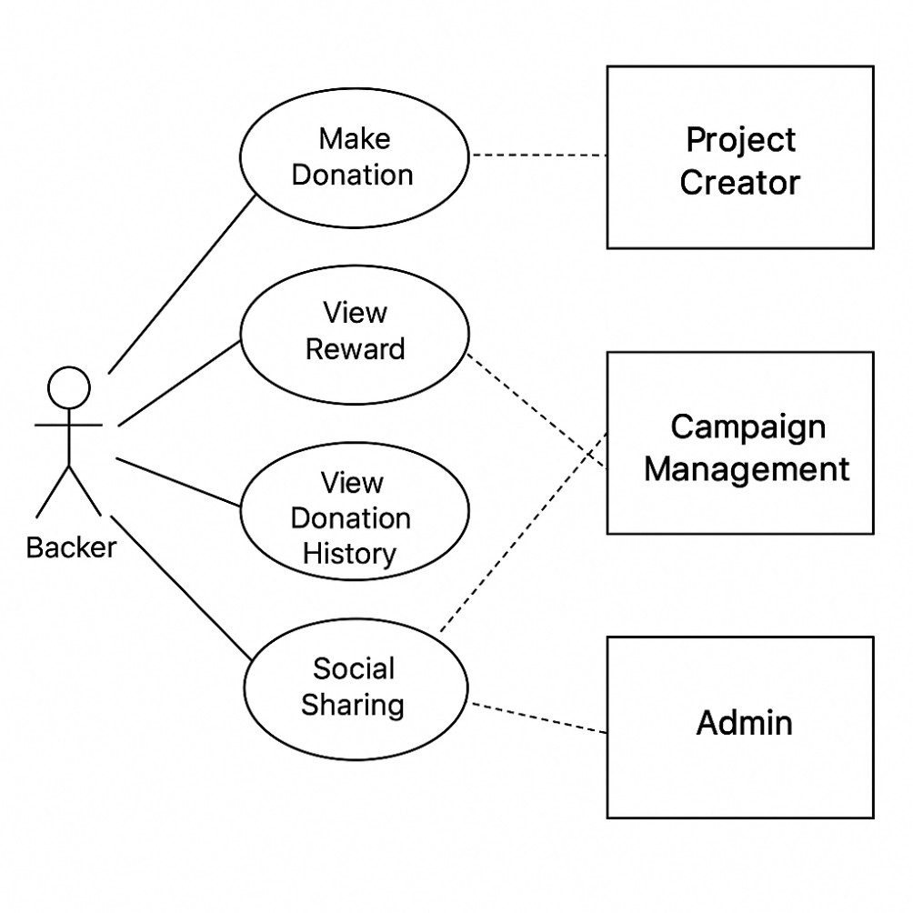
Figure 4.2 Use Case Diagram

4.4 DATA FLOW DIAGRAM
A Data Flow Diagram (DFD) is a graphical representation that illustrates how data flows through a system. It shows the sources of data, the processes that transform it, the data stores where it is kept, and the outputs that result from the system.
DFDs provide a clear visualization of how inputs are processed to generate outputs, making it easier to analyze and improve the system’s design.
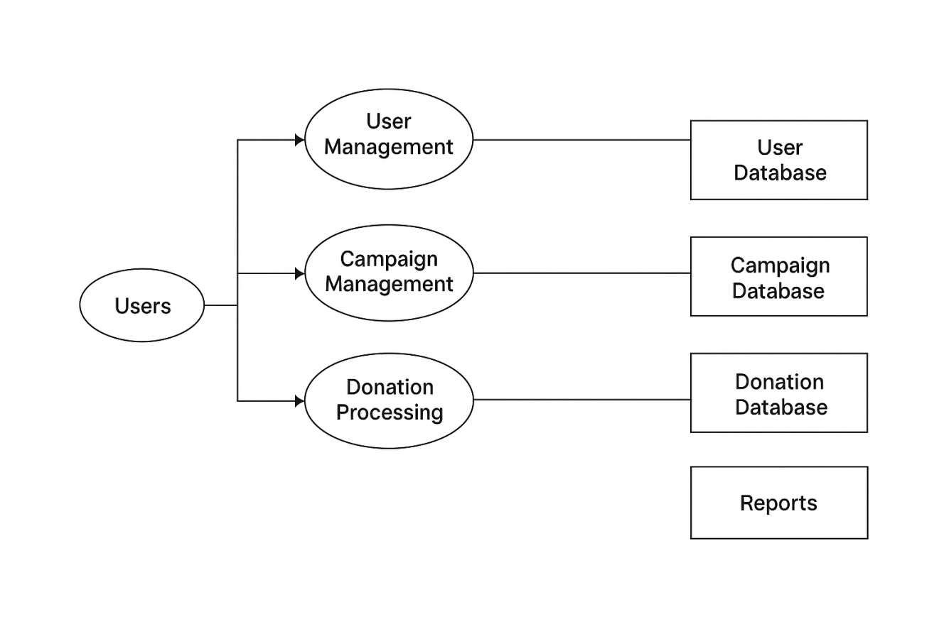
Figure 4.3 Data Flow Diagram
DATA FLOW COMPONENTS
A Data Flow Diagram (DFD) is a visual representation that shows how data moves through a system. It illustrates where data comes from (input), how it is processed (processes), where it is stored (data stores), and where it goes (output). It helps developers, analysts, and stakeholders understand the system’s workflow clearly before implementation.
External Entities – Sources or destinations of data outside the system.
- Shape – Rectangle
Processes – Activities that transform input data into output data.
- Shape – Circle or Round Rectangle
Data Stores – Places where data is stored for future use.
- Shape - Open-ended Rectangle (two parallel lines or one side open)
Data Flows – Paths that show the movement of data between entities, processes, and data stores.
- Shape – Arrow Lines
4.5 CLASS DIAGRAM
A Class Diagram is a type of UML (Unified Modeling Language) diagram that represents the static structure of a system. It shows the system’s classes, their attributes (data), methods (behavior), and the relationships between them. Class diagrams are essential in object-oriented design because they provide a blueprint for how different objects will interact within the system.
- Defining the data structure of the system.
- Specifying the responsibilities of each class.
- Showing how classes are related through association, inheritance, aggregation, or composition.
- Improving clarity for both developers and stakeholders before actual coding begins.
Components of a Class Diagram
- Classes – Represent entities or objects in the system. Each class contains attributes (data) and operations (methods).
- Example: User, Donation, Campaign
- Attributes – Define the properties of a class.
- Example: User → userId, name, email, password
- Methods (Operations) – Represent the functions or behaviors of a class.
- Example: User → register(), login()
- Relationships – Show how classes are connected.
- Association: A general connection between classes (e.g., User → Donation).
- Inheritance: When one class derives from another (e.g., Admin inherits from User).
- Aggregation/Composition: Represent whole-part relationships (e.g., Campaign contains Donations).
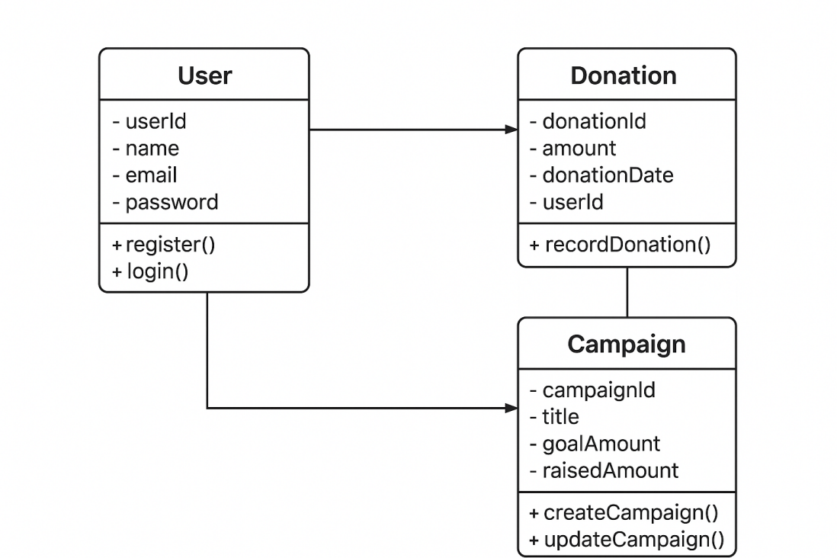
Figure 4.4 Class Diagrams
4.5 SEQUENCE DIAGRAM
The sequence diagram shows how different entities (Donor, Fundraising System, Admin, and Database) interact step-by-step when a donor contributes to a fundraising campaign. It highlights the chronological flow of messages and actions.
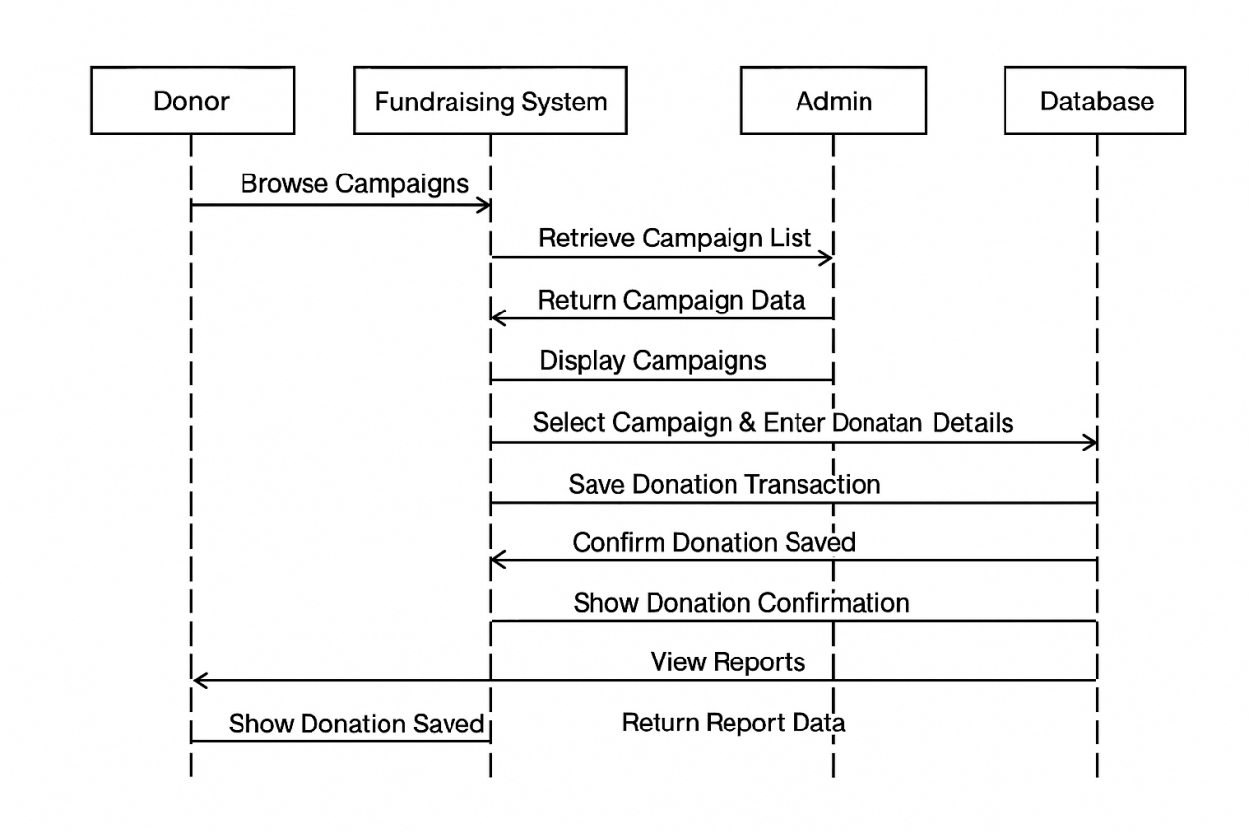
Figure 4.5 Sequence Diagram
4.6 ACTIVITY DIAGRAM
An Activity Diagram is a UML behavioral diagram that represents the sequence of activities and the flow of control in a system. It is used to model workflows and business processes, capturing both sequential and parallel actions. In the Digital Fundraising Project, the activity diagram visually illustrates how users (donors and campaign owners) and the system interact to complete key processes such as user registration, campaign creation, donations, and reporting.
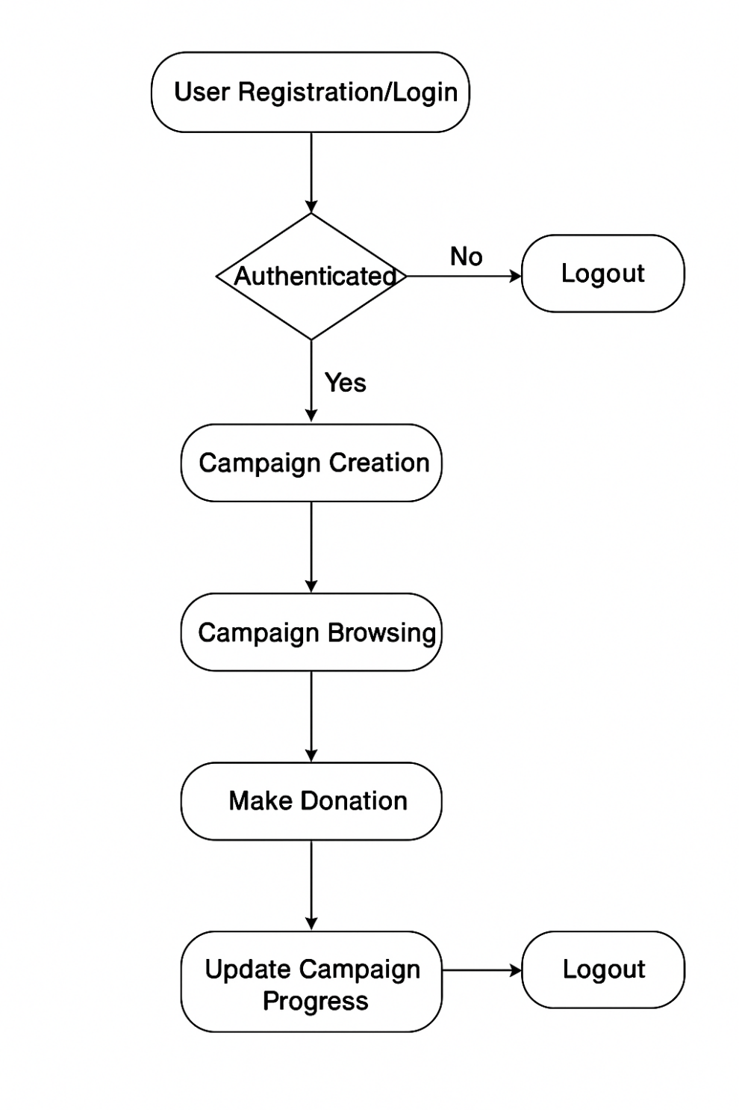
Figure 4.6 Activity Diagram
4.3.2 DATA STRUCTURES
Data Structures are the way you organize, store, and manage data so that it can be processed efficiently. They provide a systematic format to store data in memory or a database and allow easy insertion, retrieval, updating, and deletion of information.
Table 4.1 User Table
S.no | Field Name | Null | Type
1 | User_Id | Not Null | Int
2 | Name | Not Null | Varchar
3 | Email | Not Null | Varchar
4 | Password | Not Null | Varchar
5 | Role | Not Null | Varchar

Table 4.2 Campaigns Table
S.no | Field Name | Null | Type
1 | Campaign_id | Not Null | Int
2 | User_id | Not Null | Int
3 | Title | Not Null | Varchar
4 | Desciption | Not Null | Varchar
5 | Goal_amount | Not Null | Decimal
6 | Start_date | Not Null | Date
7 | End_date | Not Null | Date
8 | Status | Not Null | Enum

Table 4.3 Donations Table
S.no | Field Name | Null | Type
1 | Donation_id | Not Null | Int
2 | Campaign_id | Not Null | Int
3 | User_id | Not Null | Int
4 | Amount | Not Null | Decimal
5 | Donation_date | Not Null | Date
6 | Payment_method | Not Null | Varcar

4.4 USER INTERFACE DESIGN
User Interface Design in a project is the process of designing the screens, pages, and visual elements (like buttons, menus, input boxes, forms) that allow users to interact with the system easily and effectively.
It focuses on simplicity, clarity, and user experience so that donors, campaign organizers, and admins can navigate the system without difficulty.
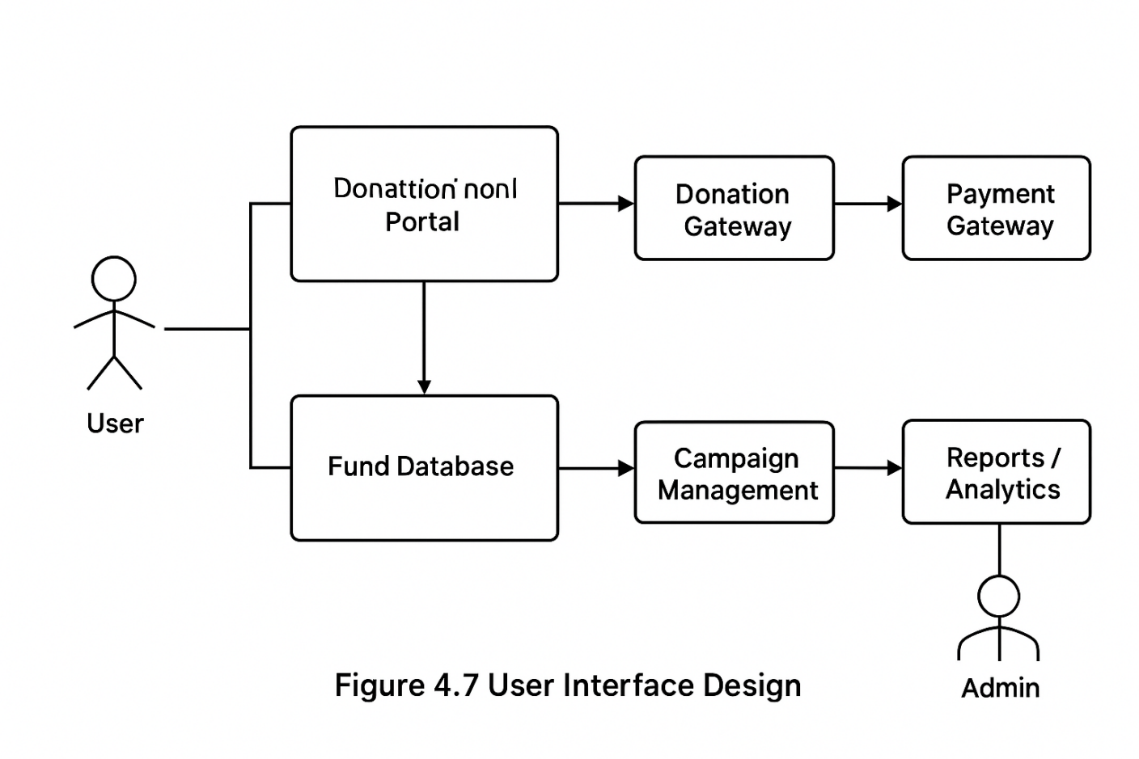
Figure 4.7 User Interface Design
4.5 RISK LIST
Every project carries certain risks that can impact its success, performance, and overall sustainability. For a Digital Fundraising System, risks mainly revolve around security, system reliability, data integrity, user trust, and legal compliance. Identifying these risks in advance and planning effective mitigation strategies ensures that the system remains secure, reliable, and user-friendly.
Table 4.4 Rist List
Risk Ranking magnitude | Risk Desctiption and Impact | Mitigation Strategy
1 | Unauthorized access to donor or fundraiser data could lead to data breaches and privacy violations, reducing user trust. | Unauthorized access to donor or fundraiser data could lead to data breaches and privacy violations, reducing user trust.
2 | Payment gateway failures or transaction errors could block or delay donations, affecting campaign progress. | Integrate multiple payment gateways, provide transaction retry mechanisms, and enable real-time monitoring of payment services.
3 | Server downtime or hosting failures may interrupt fundraising activities, leading to financial loss and user dissatisfaction. | Use cloud hosting with auto-scaling, regular data backups, and disaster recovery planning.

4.6 TEST CASE DESIGN
Test Case Design is the process of preparing test cases that validate whether the project functions correctly under different scenarios. It specifies the test ID, module, scenario, steps, expected result, and status.
Table 4.5 Test Case Design

Test Case ID | Module | Test Scenario | Test Steps | Expected Results | Status (pass/fail)
TC01 | User Registration | Register a new user (donor/fundraiser) | Open registration form → Enter valid details → Submit | User account created successfully, confirmation sent | Pass
TC02 | User Login | Authenticate user credentials | Enter correct and incorrect credentials → Submit | Correct → Login successful; Incorrect → Access denied | Pass
TC03 | Campaign Creation | Create a fundraising campaign | Login as fundraiser → Fill campaign form → Submit | Campaign created and listed under "Active Campaigns" | Pass
TC04 | Donation Processing | Make a donation to a campaign | Select campaign → Enter donation amount → Pay via payment gatewa | Donation processed successfully, confirmation email sent | Pass
TC05 | Fraudulent Campaign Handling | Attempt to create fake campaign | Login as fundraiser → Enter invalid or suspicious details → Submit | System flags/blocks suspicious campaign, not approved | Pass
TC06 | Payment Failure Handling | Simulate failed transaction | Choose campaign → Enter donation → Cancel/Fail payment | System shows "Payment Failed", donation not recorded | Pass
TC07 | Unauthorized Access | Access admin features as normal user | Login as donor/fundraiser → Try accessing admin dashboard | Access denied with warning message | Pass
TC08 | Report Generation | Generate fundraising report | Login as admin → Select "Reports" → Generate | Report generated with accurate data | Pass
TC09 | Data Backup & Recovery | Test system during database crash | Disconnect database → Perform donation → Reconnect | System handles gracefully, no data loss | Pass
TC10 | Logout Functionality | User logs out of system | Click on logout button | User session terminated, redirected to login page | Pass

